**FREQUENCY REUSE ALGORITHM**

**Introduction:**

Frequency Reuse Techniques are required to satisfy the exponential increase of data demands in mobile net-works, such as the Long Term Evolution (LTE) network of Universal Mobile Terrestrial radio access System (UMTS). However, the simultaneous usage of the same Frequency in adjacent LTE cells creates inter-cell interference problems at cell-edge users.

Inter-Cell Interference Coordination (ICIC) techniques are deployed to avoid the negative impact of interference on system performance. This study classified the existing ICIC techniques and investigates the performance of reuse-1, reuse-3 schemes under various user distributions. Performance of cell-center and cell-edge users is inspected, as well as the overall spectral efficiency, throughput and network load. System level simulations are performed that shows the advantages and limitations of each of the examined techniques under different user distributions which is used to determine the most suitable ICIC technique to be used.

**Why frequency reuse:**

In wireless communication each cell has its own transmitter (Base Stations) and group of channels. Normally these channels are 8 to 10 channels in which some channels are used for voice control and some for data control. In this way if in a city there are 100 base stations then the corresponding number of channels goes to 1000s but a fixed spectrum has been allocated by the TRAI (Telecom Regulatory Authority of India). If each channel has its own frequency bandwidth then the spectrum will go in gigabytes. That is beyond the control of TRAI. Therefore I need to find a solution to manage these channels.

**Types of Frequency reuse algorithms:**

**HARD FREQUENCY REUSE:**

The Hard Frequency Reuse algorithm provides the simplest scheme which allows to reduce inter-cell interference level. In this scheme whole frequency bandwidth is divided into few (typically 3, 4, or 7) disjoint sub-bands. Adjacent eNBs are allocated with different sub-band. Frequency reuse factor equals the number of sub-bands

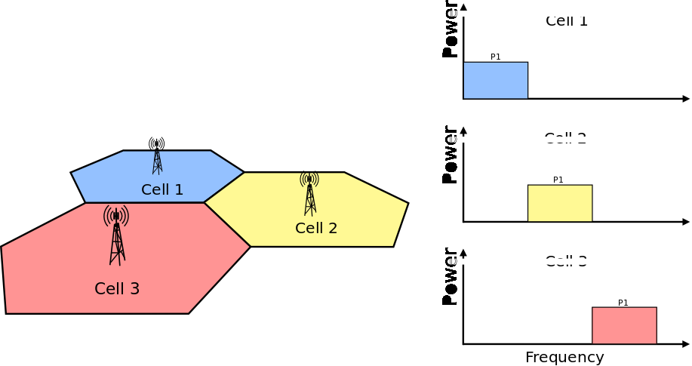

**STRICT FREQUENCY REUSE:**

Strict Frequency Reuse scheme is a combination of Full and Hard Frequency Reuse schemes. It consists of dividing the system bandwidth into two parts which will have different frequency reuse. One common sub-band of the system bandwidth is used in each cell interior (frequency reuse-1), while the other part of the bandwidth is divided among the neighboring eNBs as in hard frequency reuse (frequency reuse-N, N>1), in order to create one sub-band with a low inter-cell interference level in each sector. Center UEs will be granted with the fully-reused frequency chunks, while cell-edge UEs with orthogonal chunks. It means that interior UEs from one cell do not share any spectrum with edge UEs from the second cell, which reduces interference for both.

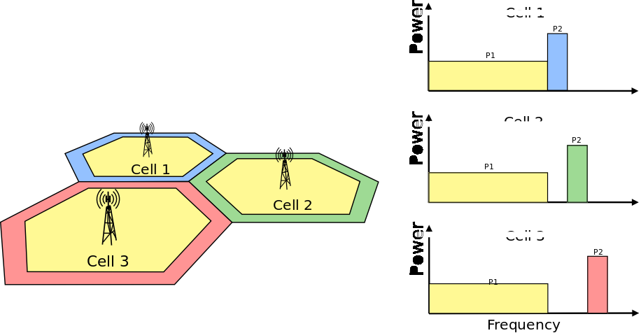

**SOFT FREQUENCY REUSE**

In Soft Frequency Reuse (SFR) scheme each eNb transmits over the entire system bandwidth, but there are two sub-bands, within UEs are served with different power level. Since cell-center UEs share the bandwidth with neighboring cells, they usually transmit at lower power level than the cell-edge UEs. SFR is more bandwidth efficient than Strict FR, because it uses entire system bandwidth, but it also results in more interference to both cell interior and edge users.

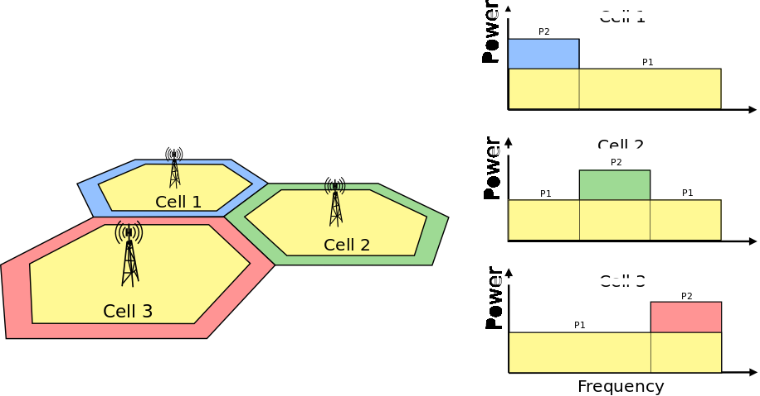

**SOFT FRACTIONAL FREQUENCY REUSE**

Soft Fractional Frequency Reuse (SFFR) is a combination of Strict and Soft Frequency Reuse schemes. While Strict FR do not use the subbands allocated for outer regions in the adjacent cells, soft FFR uses these subbands for the inner UEs with low transmit power. As a result, the SFFR, like SFR, uses the subband with high transmit power level and with low transmit power level. Unlike the Soft FR and like Strict FR, the Soft FFR uses the common sub-band which can enhance the throughput of the inner users.

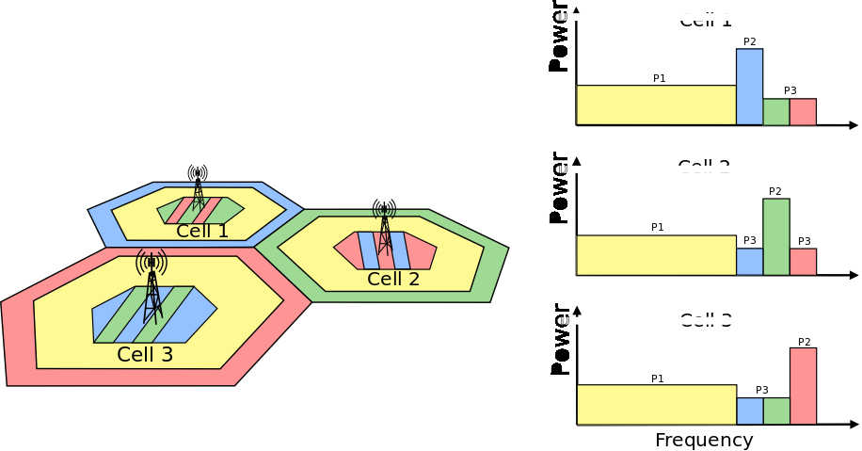

**Types of Frequency reuse algorithms available in ns3**

* ns3::LteFrNoOpAlgorithm
* ns3::LteFrHardAlgorithm
* ns3::LteFrStrictAlgorithm
* ns3::LteFrSoftAlgorithm
* ns3::LteFfrSoftAlgorithm
* ns3::LteFfrEnhancedAlgorithm
* ns3::LteFfrDistributedAlgorithm

**Our goal:**

To compare between all these different algorithms with some fixed parameters and find out in which real world use case which one would be better based on throughput and then we tried to introduce an algorithm which is based upon area.

**Existing algo: FFR with Random Allocation**

In FFR, each cell is logically partitioned into center and outer areas based on fixed distance

threshold. The edge users of neighboring cells are assigned different frequency sub-bands so that they do not interfere with each other. Three sub-bands are reserved for allocation in cell edges. 30% of the total bandwidth is reserved for the edge users. The 30% is divided into three groups. Hence each sector’s edge has 10% of the total bandwidth. The region beyond the 2/3 of the cell radius is considered as the outer region or the cell edge. Since the irregularity of the cell is achieved by changing the power and the antenna tilt of the sectors, users are placed by looking at the coverage of each sector. In this allocation scheme, the three frequency sub-bands were randomly assigned to cell edges of each cell sector without considering neighbor relation or overlap between coverage of cell sites.

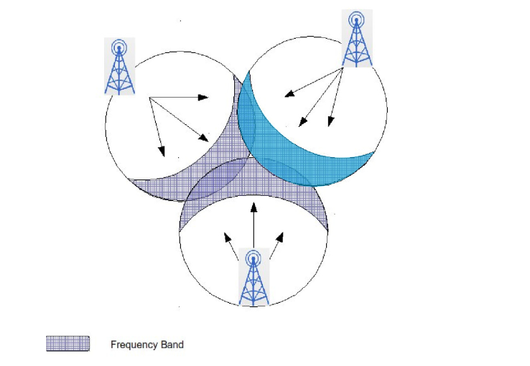

Same sub-bands in neighboring cells in FFR3-RFA.

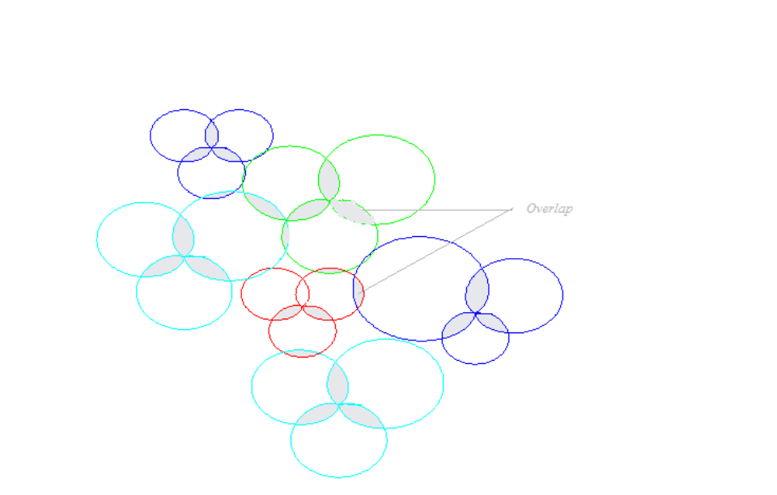

Real life scenarios with different cell size,uneven overlaps.

**Proposed algo: FFR-3 with Algorithmic Allocation**

The frequency allocation scheme that we will use for the simulations is FFR-3 with

algorithmic frequency allocation. The algorithm’s objective is to optimize the cell edge

performance. The main idea is that instead of randomly allocating sub-bands, cell edges are

assigned frequency sub-bands by taking into consideration the allocated sub-bands to cell

neighbors as well as the degree of overlap between the neighboring cells. By introducing

These constraints, close to real-life scenarios for frequency allocation, were attempted.

The optimization procedure aims to further improve the throughput achieved by cell edge

users. In other words, the frequency sub-bands are allocated to cell edges in such a way that

the same sub-bands are kept as far as possible.

**Example:** Suppose we have a large cell A which has many smaller cells as its

neighbors. If only three frequency sub-bands are available for allocation to cell edges, there

is a possibility that one of the neighbors of cell A will end up having the same frequency at

its edge as the large cell A’s outer region. This is where optimization comes into play because

We know that a collision is inevitable. We can shift this collision such that the overall damage

is minimum. For example, cell C, a smaller cell neighboring to A, has been allocated the

same cell edge frequency as that assigned to the cell edge of cell A. We assume that cell C

and cell A has a large overlap area. It would be a better solution to assign the conflicting

sub-band to some other neighbor of cell A that has a lesser overlap area than the overlap area

of cell A and cell C. This will lead to less interference for users in the overlap regions of cells

A and C, and hence improved overall throughput for the system.

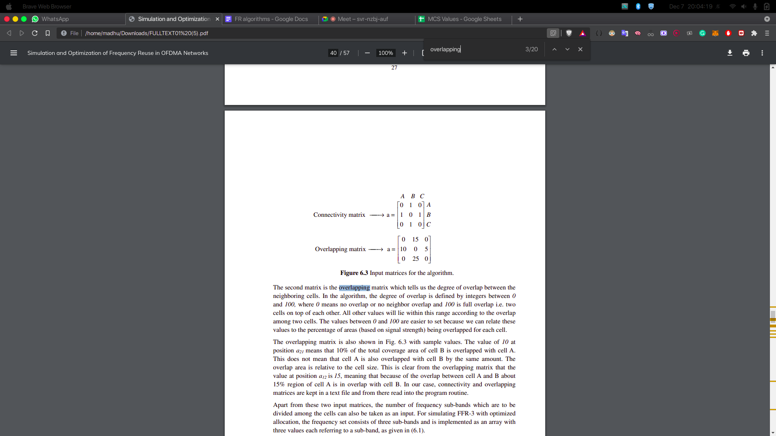

**REM files:-**

The Simulation Results generated (Radio Environment Map) REM file which shows the SINR (Signal to Interference Noise Ratio )in decibels. Hard Fr uses the entire band and has the highest SINR strongest at center. Soft Frequency reuse and Soft Fractional frequency reuse is found to have a decrease in transmitting power at the center area. Enhanced Fractional frequency reuse REM also shows the good uniform SNIR as shown in figure below.

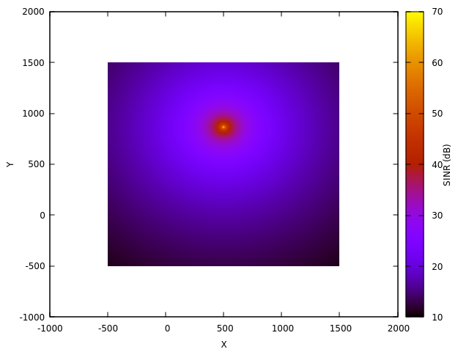

**Hard**

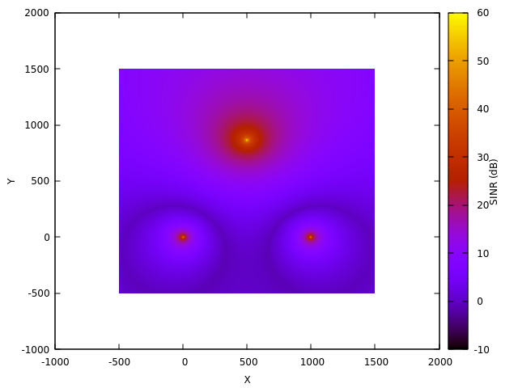

**Soft FR**



**Soft FFR**

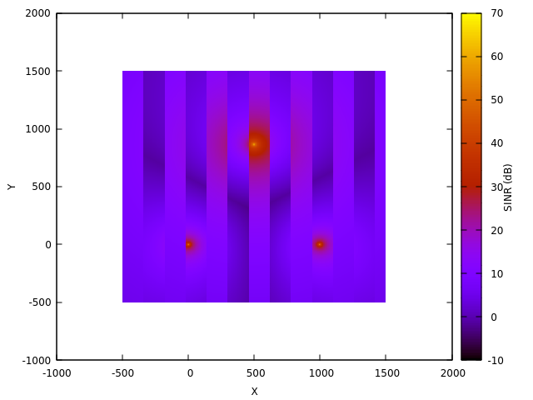

**Enhanced FFR**

* **Area based algorithm**

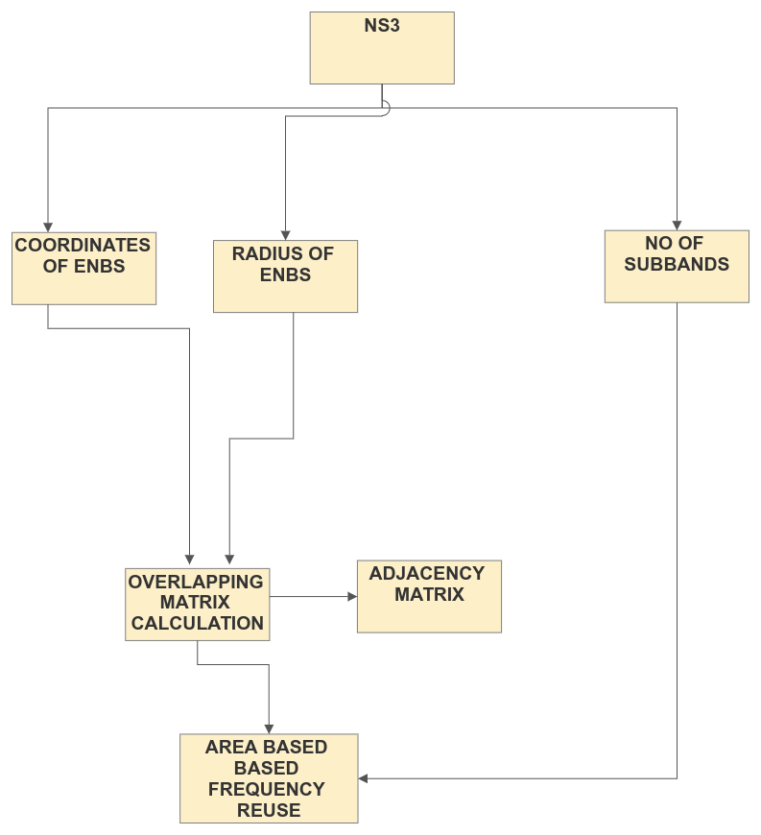

**Flow chart**

**Inputs taken from ns3:**

Coordinates of nodes

Adjacency matrix

Radius=20

Subbands available: 24 [0-23]

**Results:**

1. Overlapping matrix: [Overlapping_matrix.txt](https://drive.google.com/file/d/1N5Ib98cfsMwpOdKUS_6GD9wJidU4KINW/view?usp=sharing)
2. Subbands allocations:

Subbands available: 24

[3, 18, 12, 6, 11, 10, 13, 21, 19, 2, 14, 4, 1, 5, 7, 16, 8, 20, 23, 9, 22, 15, 17, 2, 5, 17, 10]

Subbands available:15

[3, 14, 8, 7, 13, 12, 4, 6, 11, 9, 10, 2, 1, 5, 10, 10, 7, 4, 6, 2, 13, 14, 1, 4, 13, 10, 14]

* [Drive link of the project](https://drive.google.com/drive/folders/1MvNN959z40nDJnXdSxHjazgwNBEU1liO?usp=sharing) :- All codes and findings are available here.

**References:**

<https://www.nsnam.org/docs/tutorial/html/getting-started.html>

<https://www.nsnam.org/docs/models/html/lte-user.html#frequency-reuse-algorithms>

<https://www.nsnam.org/docs/models/html/lte-design.html#sec-fr-hard-algorithm>